# Speaking cards

# PASSIVE VOICE

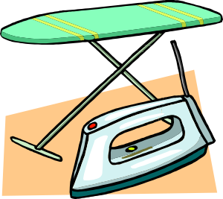

* Were many photos made by you last month?
* Are you often sent on business trips?
* Will new restaurants be built in your city?
* How many new words were learnt by you yesterday?
* Will any new things be bought by you next week?
* Were you given many presents as a child?
* Were you sent many messages yesterday?
* Will new trees be planted in your city?
* Are you often asked for help?
* Were you told an interesting story yesterday?
* Will many friends be invited for your next birthday?
* Have you been invited

to the party recently?

* Are you allowed to come home late

at night?

* Were your clothes ironed yesterday?
* Have you been prescribed any medicine recently?
* Was your cell phone bought last year?
* Will new schools be built in your city?
* Are your problems discussed with

your close friend?

* Was your English book bought by you?
* Have the dishes been washed today?
* Was your pet given food yesterday?
* Are your shoes made from leather?
* Was your breakfast cooked by you today?
* Will your apartment be

cleaned tomorrow?